15.3 Editors - Dope Sheet - Sidebar
Dopesheet Editor - Sidebar 2
Sidebar - Marker options panel 2
Lock Markers 2
Sync Markers 2
Sidebar - View options panel 2
Realtime Updates 2
Show Markers 2
Show Seconds 2
Sync visible range 2
Show Sliders 2
Show Group Colors 3
Show Handles and Interpolation 3
Show Curve Extremes 3
AutoMerge Keyframes 3
Sidebar - Layer panel 3
Blend 4
Opacity 4
Use Lights 4
Autolock Inactive Layers 4
Masks 4
Enable 4
Layer Specials 4
Mask layer list 4
Layer name 4
Invert 4
Hide 4
Search 4
Invert 4
Resize 5
Adjustments 5
Tint color 5
Factor 5
Stroke Thickness 5
Pass Index 5
View Layer 5
Disallow Locked Materials Editing 5
Relations 5
Parent 5
Type 5
Display 5
Custom channel color 5
Show only on keyframed 5

Dopesheet Editor - Sidebar
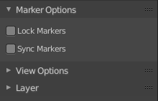
The sidebar contains further options.

Sidebar - Marker options panel

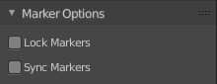
Lock Markers
Make the markers uneditable.

Sync Markers
Sync markers with keyframe edits. When you move the keyframes, then the markers will move too.

Sidebar - View options panel
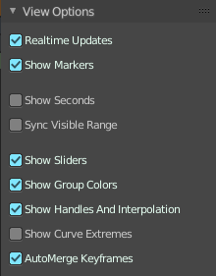
Some of these settings belongs to the Graph editor. But can also be changed from the Dope Sheet editor.

Realtime Updates
When transforming keyframes then this transformation is also immediately visible in other editors.

Show Markers
Display the markers row at the bottom of the view.

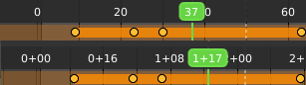
Show Seconds
Show the timing in the timeline area in seconds instead of frames.

Sync visible range
Synchronize the visible timeline range with other visible time based editors.

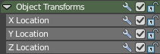
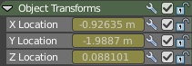
Show Sliders
Shows the value sliders for f-curve channels in the channel list.

Show Group Colors
Display groups and channels with colors matching their corresponding groups (pose bones only currently)
Not documented, not to find out how it works. Not even with bones in pose mode as suggested. This checkbox seems to do nothing.

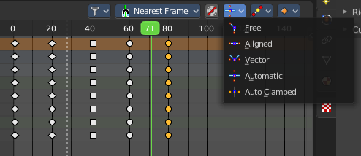
Show Handles and Interpolation
With this option on the keyframes shows different shapes that depends of their handle type.
With this option off all keyframes shows as diamond shape.

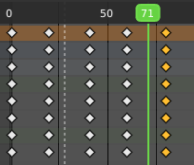

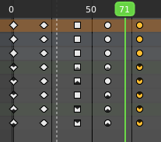
Show Curve Extremes
Shows the curve extremes at the keyframe icons.

AutoMerge Keyframes
Automatically merge nearby keyframes.

Sidebar - Layer panel

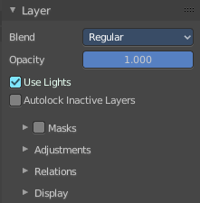
Grease Pencil mode only. This panel contains further settings for the grease pencil layers.

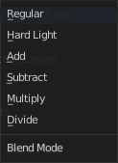
Blend
The blend mode for the current layer.

Opacity
The layer opacity

Use Lights
Enable the use of lights on stroke and fill materials.

Autolock Inactive Layers
Lock automatically all layers except active one to avoid accidental changes.

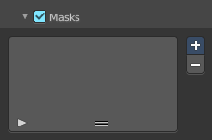
Masks
Use masking.

Enable
Activate the use of masks. Every existing grease pencil layer can be used as mask.

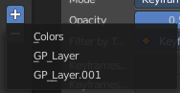
Layer Specials
Choose the grease pencil layer that you want to add and use as a mask.

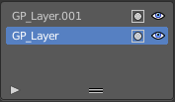
Mask layer list
The list of the mask layers.

Layer name
The name of the layer. Double clicking at it enables to edit the name.

Invert
Invert the mask.

Hide
Show or hide the mask.

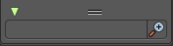
Search
At the end of the list you will find a search field. It can be revealed by clicking at the triangle button. Type in the term that you want to search for.

Invert
Inverts the filtering of the content.

Resize
The list can be resized by the handler with the two lines at the bottom.

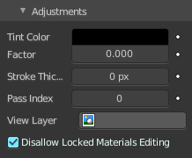
Adjustments

Tint color
The color for tinting stroke colors. This prop can be animated by clicking the Animate Property button at the end.

Factor
The factor for color tinting. This prop can be animated by clicking the Animate Property button at the end.

Stroke Thickness
Thickness change to apply to the current strokes in pixels. This prop can be animated by clicking the Animate Property button at the end.

Pass Index
Index number for the layer index pass. This prop can be animated by clicking the Animate Property button at the end.

View Layer
Only include layer in this View Layer render output. Leave blank to include always.

Disallow Locked Materials Editing
Avoids editing locked materials in the layer.

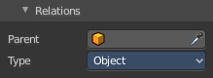
Relations

Parent
Parent object.

Type
The object type to parent to.

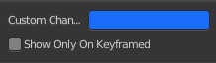
Display

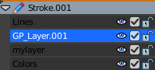
Custom channel color
Give the selected channels another color in the channels list.

Show only on keyframed
In Paint mode display only layers with keyframe in current frame.

